



Refrigeration and Air Conditioning – Minimum Australian Context Gap Course
(10146NAT)

Expression of Interest

INSERT DATE

Organisation Details
Registered business:
ABN:
Trading names:
TGA provider code:
CRICOS provider code:
Registered Business Street Address: |  | Address
 |  | Suburb:
 |  | State: |  |  |  |  |  | Postcode:
Postal address (Only if different from registered business address): |  | Address
 |  | Suburb:
 |  | State: |  |  |  |  |  | Postcode:
Details of person(s) responsible for the application
- Primary Contact :
Title: |  | Mr |  |  | Mrs | Miss |  |  | Ms
First Name:
Last/Family/Surname Name:
Position:
Telephone: |  | (W) |  |  |  | Mobile:
Email:
- Secondary Contact :
Title: |  | Mr |  |  | Mrs | Miss |  |  |  | Ms
First Name:
Last/Family/Surname Name:
Position:
Telephone: |  | (W) |  |  |  |  | Mobile:
Email:
- Resources Contact (to distribute support documents to):
Same as above |  | Primary Contact |  |  |  |  | Secondary Contact
Title: |  | Mr |  | Mrs |  |  | Miss |  |  |  | Ms
First Name:
Last/Family/Surname Name:
Position:
Telephone: |  | (W) |  |  |  |  | Mobile:
Email:
Background and Structure of the Organisation
URL:
Overview of Organisations Industry Knowledge and Experience in delivery of Refrigeration and Air Conditioning Training:

Current Scope of Registration: | Code : | Name :

Course Methodology

Overview:

This course provides Minimum Australian Context Gap training to holders of an Onshore or Offshore Technical Skills Record (OTSR) for the UEE32211 Certificate III in Refrigeration and Air Conditioning or its successor. When this Statement of Attainment is completed and presented to the RTO responsible for issuing the OTSR, together with evidence of sufficient workplace experience and performance (Profiling), it will trigger the issuance of the national qualification UEE32211 Certificate III in Refrigeration and Air Conditioning qualification or its successor.

NOTE: This course includes content derived from UEE32211 Certificate III in Refrigeration and Air Conditioning competency standard units from the UEE11 Electrotechnology Training Package or its successor.

Nominal duration of the course: 165 hrs

The establishment of an OTSR has meant that the assessment process undertaken either onshore or offshore does not result in the issuance of a full unit of competency or qualification, instead an OTSR documents that successful demonstration of the generic technical aspects of all competency standard units across the qualification have been verified.

Since applicants commenced arriving in Australia under the onshore or offshore skilled migration process some candidates have struggled to access an RTO to deliver the identified Australian Context Gap. Additionally, RTOs have been reluctant to deliver this training to candidates due to thin markets and a lack of flexibility and other constraints.

As a result, Energy Skills Australia with the support of The Department of Education, Employment and Workplace Relations has developed this accredited course to enable RTOs, under licence to Energy Skills Australia, to deliver the course and grant a Statement of Attainment to verify they have met the Australian Minimum Context Gap and can be issued the full qualification by the OTSR issuing organisation or the GAP Training Organisation , once they provide evidence of sufficient workplace experience and performance using a profiling system specific to the Australian Minimum Context Gap Course.

RTO’s responding to the EOI must consider how they will deliver the course an efficient, accessible, cost effective way to small numbers of applicants from a range of backgrounds.

This course is only accessible by OTSR holders for the UEE32211 Certificate III in Refrigeration and Air Conditioning or its successor.

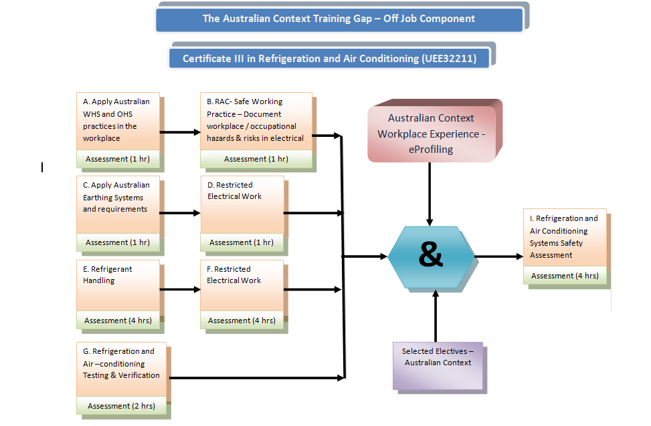

Units:
In order to be issue with a Statement of Attainment Refrigeration and Air Conditioning – Australian Minimum Context Gap, candidates must successfully achieve all of the Core Units of Competency (UOC) and one Elective (UOC)

Statement of Attainment For Course in Refrigeration and Air Conditioning - Minimum Australian Context Gap
Course Number | 10146NAT
Entry for this course will be strictly limited to holders of an Offshore Technical Skills Record (OTSR) for the UEE32211 Certificate III in Refrigeration and Air Conditioning qualification from the UEE11 Training Package or its equivalent successor.

Holders of this OTSR will have already demonstrated the recommended LL&N skills for the completion of this course.

Learners must also either be in relevant employment or have access to appropriate workplace environments to achieve the completion requirements of this course.

This course consists of core and elective competency standard units to provide the required Australian Minimum Context Gap training for those issued with an Offshore Technical Skills Record (OTSR) for the UEE32211 Certificate III in Refrigeration and Air Conditioning qualification from the UEE11 Version 1 Training Package or its equivalent successor.

The requirements for granting this course will be met when competency is demonstrated and achieved for:
  - All of the Core competency standard units, and
  - One Elective competency standard unit

- To achieve a competency standard unit you must provide sufficient evidence of an understanding of the required skills and knowledge and relevant workplace experience/ performance as prescribed in each unit. All the required pre-requisite competency standard units must be achieved prior to completing each competency standard unit.

Core Competency Standard Units
All Core competency standard units to be achieved
Unit code | Unit title | Pre-requisite | Nominal hours
ECGELE001A | Apply Australian WHS practices in the workplace | Nil. | 9
ECGRAC001A | Document occupational hazards and risks in refrigeration and air-conditioning | ECGELE001A | 5
ECGRAC002A | Apply Australian Standards to RAC low voltage circuits | ECGELE001A and ECGRAC001A | 10
ECGRAC003A | Disconnect and reconnect fixed wired electrical equipment connected to a Low Voltage supply | ECGELE001A, ECGRAC001A and ECGRAC002A | 27
ECGRAC004A | Recover, pressure and leak test, evacuate and charge refrigerants | ECGELE001A, ECGRAC001A, ECGRAC002A and ECGRAC003A | 41
ECGRAC005A | Install refrigeration and air conditioning systems | ECGELE001A, ECGRAC001A, ECGRAC002A, ECGRAC003A and ECGRAC004A | 41
ECGRAC006A | Diagnose and rectify faults in refrigeration and air conditioning systems and components | ECGELE001A, ECGRAC001A, ECGRAC002A, ECGRAC003A, ECGRAC004A and  ECGRAC005A | 18
ECGRAC007A | Verify compliance and functionality of Australian refrigeration and air conditioning installations | ECGELE001A, ECGRAC001A, ECGRAC002A, ECGRAC003A, ECGRAC004A,  ECGRAC005A and ECGRAC006A | 4
Total Nominal Hours in Core |  |  | 155

Elective Competency Standard Units
1 units to achieve a total of 10 nominal hours
Unit code | Unit title | Pre-requisite | Nominal hours
ECGRAC008A | Solve problems in beverage dispensers | ECGELE001A, ECGRAC001A, ECGRAC002A, ECGRAC003A, ECGRAC004A,  ECGRAC005A and ECGRAC006A | 10
ECGRAC009A | Solve problems in central plant air conditioning systems | ECGELE001A, ECGRAC001A, ECGRAC002A, ECGRAC003A, ECGRAC004A,  ECGRAC005A and ECGRAC006A | 10
ECGRAC010A | Solve problems in ice making systems | ECGELE001A, ECGRAC001A, ECGRAC002A, ECGRAC003A, ECGRAC004A,  ECGRAC005A and ECGRAC006A | 10
ECGRAC011A | Solve problems in industrial refrigeration systems | ECGELE001A, ECGRAC001A, ECGRAC002A, ECGRAC003A, ECGRAC004A,  ECGRAC005A and ECGRAC006A | 10
Total Nominal Hours in Electives |  |  | 10
(All 7 of the Core and 1 Elective) Total Nominal Hours |  |  | 165

License fee for maintenance:

Please note that there will be a License fee for maintenance purposes, charged to successful RTOs. This fee will cover the continual development and evaluation of support material and resources to assist RTOs in their delivery.

RTOs will be charged at a cost $150 per candidate.

RTO Selection Criteria

Applicants must meet the course’s selection criteria listed below in order to proceed with an extension of scope application to your State Training Authority/ASQA:

- Holds current registration as identified on training.gov.au (TGA) and the RTO number has been provided
- RTO Registered name aligns with the advised ABN number
- Next scope review date will be considered
- Time frame for which you been a registered RTO is sufficient enough to have delivered the full qualification
- Currently holds the Qualification UEE32211 Certificate III in Refrigeration and Air Conditioning on scope or its successor.
- Qualification UEE32211 Certificate III in Refrigeration and Air Conditioning has been on scope for sufficient time to deliver the full qualification or its successor
- Are currently delivering the Qualification UEE32211 Certificate III in Refrigeration and Air Conditioning or its successor
- Have indicated a sufficient number of students are currently enrolled in the Qualification UEE32211 or its successor
- Acknowledge that you have read the Course Methodology and indicated they have a clear understanding of the requirements
- Sufficient evidence to confirm your facilities and equipment are adequate and meet industry expectations including distance learning (based on Pink Slip RTO evaluation process)
NOTE: Please click on the following link to review the Pink Slip process and documents: http://www.Energy Skills Australia.com.au/index.php?option=com_content&task=view&id=238&Itemid=39
- Sufficient evidence to confirm your Delivery and Assessment material meets UEE11 Electrotechnology Training Package requirements or its successor
- Have indicated that in applying for and on acceptance of delivery for this course you will be entering an agreement to support the candidates to achieve their Statement of Attainment and relevant national Electrotechnology Training Package qualification
- Will ensure that an Energy Skills Australia approved profiling system is used and that students are enrolled in the profiling system
- You have provided an indicative total and per unit cost to applicant for the delivery of the course of training including any specific course requirements
- Your indicative costing is reasonable
- You have selected a License fee rate for maintenance purposes

Response to Selection Criteria
Hold current RTO registration according to TGA |  |  |  | Yes |  | No
RTO registered name aligns with the advised ABN |  |  |  | Yes |  | No
According to TGA, current RTO registration timeframe |  |  |  | Commenced
 |  |  |  | Renewal date
Qualification UEE32211 Certificate III in Refrigeration and Air Conditioning currently on Scope |  |  |  | Yes |  | No
I have read the Course Methodology and have a clear understanding of the requirements |  |  |  | Yes |  | No
UEE32211 Certificate III in Refrigeration and Air Conditioning | Number of students currently enrolled |  |  | Actual number of training hours (OFF-JOB)
Facilities and equipment are adequate and meet industry expectations including for distance learning (based on Pink Slip RTO evaluation process). |  |  |  | Yes |  | No
Delivery and Assessment material meet Training Package requirements. |  |  |  | Yes |  | No
Comments on trainer/assessor qualifications
Delivery Experience:
Risk Assessment:
Delivery Plan and Support:
Understand that in applying for and on acceptance of delivery for this course you will be entering an agreement to support the candidates achieve their Statement of Attainment. This will lead to the full qualification by the OTSR issuing organisation or GAP training organisation once they provide evidence of sufficient workplace experience and performance using a profiling system |  |  |  | Yes | No
Provide evidence on how you will deal with thin markets and flexibility in delivery of the gap training including distance learning
Provide an indicative, per unit, cost to applicant for the delivery of the course of training including any specific course requirements.

Provide the overall total course costs to applicant for the delivery of the course of training including any specific course requirements (for publication on the E-Oz website as an approximate costing)
License fee (maintenance purposes) | $150 per candidate
Comments

Authorisation
I hereby declare that our organisation, <INSERT ORGANISATION> meets the above selection criteria to apply for the delivery of the Refrigeration and Air Conditioning - Minimum Australian Context Gap Course. We understand approval must be given by Energy Skills Australia, in which they will grant us with a license to put forward with our application to our State Training Authority/ASQA.

Primary applicants signature: |  | Date:



