



Cable Jointing – Minimum Australian Context Gap
(10316NAT)

Expression Of Interest

INSERT DATE

Organisation Details
Registered business:
ABN
Trading names:
TGA provider code:
CRICOS provider code:
Registered Business Street Address: | Address
Registered Business Street Address: | Suburb:
Registered Business Street Address: | State: |  |  |  |  |  |  | Postcode:
Postal address (Only if different from registered business address): | Address
 | Suburb:
 | State: |  |  |  |  |  |  | Postcode:
Details of person(s) responsible for the application
- Primary Contact :
Title: | Mr |  |  | Mrs | Miss |  |  |  | Ms
First Name:
Last/Family/Surname Name:
Position:
Telephone: | (W) |  |  |  | Mobile:
Email:
- Secondary Contact :
Title: | Mr |  |  | Mrs | Miss |  |  |  |  | Ms
First Name:
Last/Family/Surname Name:
Position:
Telephone: | (W) |  |  |  |  | Mobile:
Email:
- Resources Contact (to distribute support documents to):
Same as above | Primary Contact |  |  |  |  |  | Secondary Contact
Title: | Mr |  | Mrs |  |  |  | Miss |  |  |  | Ms
First Name:
Last/Family/Surname Name:
Position:
Telephone: | (W) |  |  |  |  | Mobile:
Email:

Background and Structure of the Organisation
URL:
Overview of Organisations Industry Knowledge and Experience in delivery of Electrical Training:
Current Scope of Registration: | Code : | Name :

Course Methodology

Overview:

This course provides Minimum Australian Context Gap training to holders of an Onshore or Offshore Technical Skills Record (OTSR) for the UET30812 Certificate III in ESI — Power Systems – Distribution Cable Jointing or its successor. When this Statement of Attainment is completed and presented to the RTO responsible for issuing the Onshore or Offshore Technical Skills Record (OTSR), together with evidence of sufficient workplace experience and performance (Profiling), it will trigger the issuance of the national qualification UET30812 Certificate III in ESI — Power Systems – Distribution Cable Jointing or its successor.

NOTE: This course includes content derived from UET30812 Certificate III in ESI — Power Systems - Distribution Cable Jointing competency standard units from the UET12 Transmission, Distribution and Rail Sector Training Package.

Nominal duration of the course: 170 hrs

The establishment of an OTSR has meant that the assessment process undertaken either onshore or offshore does not result in the issuance of a full unit of competency or qualification, instead an OTSR documents that successful demonstration of the generic technical aspects of all competency standard units across the qualification have been verified.

Since applicants commenced arriving in Australia under the onshore or offshore skilled migration process, some candidates have struggled to access an RTO to deliver the identified Australian Context Gap. Additionally, RTOs have been reluctant to deliver this training to candidates due to thin markets and a lack of flexibility and other constraints.

As a result, Energy Skills Australia with the support of the Department of Education, Employment and Workplace Relations has developed this accredited course to enable RTOs, under licence to Energy Skills Australia, to deliver the course and grant a Statement of Attainment to verify they have met the Australian Minimum Context Gap and can be issued the full qualification by the OTSR issuing organisation or the GAP Training organisation, once they provide evidence of sufficient workplace experience and performance using a profiling system.

RTO’s responding to the EOI must consider how they will deliver the course an efficient, accessible, cost effective way to small numbers of applicants from a range of backgrounds.

This course is only accessible by OTSR holders for the Certificate III in ESI — Power Systems – Distribution Cable Jointing or its successor

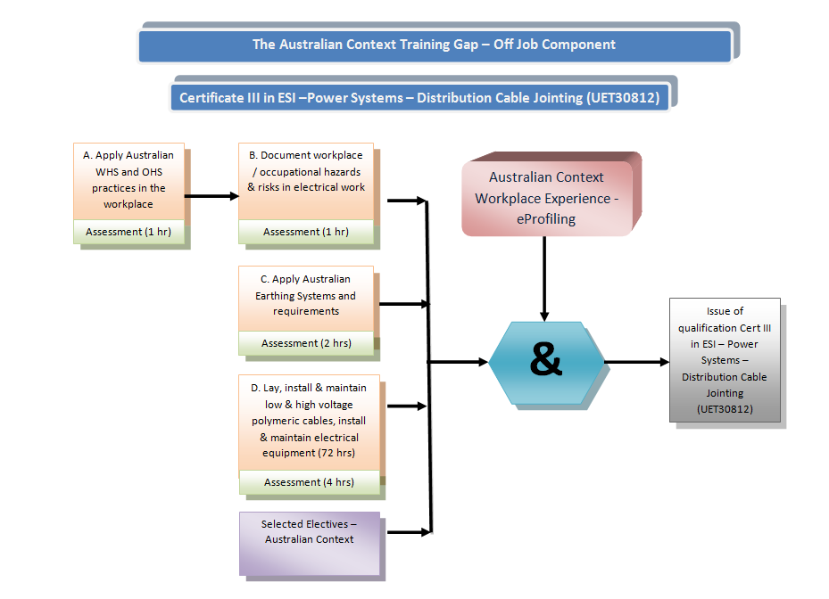

Units:

In order to be issue with a Statement of Attainment Cable Jointing – Australian Minimum Context Gap, candidates must successfully achieve all of the Core Units of Competency (UOC) and Elective Units to achieve a total of 80 nominal hours.

Statement of Attainment – Cable Jointing - Minimum Australian Context Gap Course
Course Number | 10316NAT
Entry Requirement
Entry for this course will be strictly limited to holders of an OTSR for the Certificate III in ESI — Power Systems – Distribution Cable Jointing (UET30812) or its successor.
Scope
This Statement of Attainment provides the contents to meet the relevant Australian Acts, Regulation, Codes and Standards, and State/Territories Occupational Health and Safety Legislation and Regulations for the person to perform: laying, installation and maintenance of de-energised LV and HV underground polymeric cables and the installation and maintenance of electrical equipment.
Completion requirements
The requirements for granting this statement will be met when competency is demonstrated and achieved for:
- All the Core competency standard units, and
- A combination of Elective competency standard units to achieve a total of 80 nominal hours.

Core Competency Standard Units  All Core competency standard units to be achieved |  | Pre-requisite | Nominal Time (Hrs)
EEOZAMCG01A | Apply Australian OHS practices in the workplace - AMCG | Nil | 9
EEOZAMCG02A | Document occupational hazards and risks in electrical work - AMCG | Nil | 8
EEOZAMCG05A | Apply Australian Standards to Multiple Earth Neutral (MEN) wiring circuits/ systems – AMCG | Nil | 22
ECGDCJ001A | Install and maintain de-energised underground polymeric cables, ESI infrastructure and equipment | EEOZAMCG05A | 51
Nominal Time in Core (hours) |  |  | 90

Elective Units – Complete 4 units to achieve a total of 80 nominal hours |  | Pre-requisite | Nominal Time (Hrs)
ECGDLW001A | Undertake scheduled LV field switching operations | EEOZAMCG05A | 20
ECGDLW002A | Undertake scheduled HV field switching operations | EEOZAMCG05A | 20
ECGDLW003A | Carry-out installation, testing and maintenance of LV underground services | EEOZAMCG05A | 20
ECGDCJ002A | Carry-out Installation and maintenance of de-energised, paper insulated, LV underground cables | ECGDCJ001A | 20
ECGDCJ003A | Carry-out Jointing and maintenance of energised, paper insulated, LV underground cables | ECGDCJ001A | 20
ECGDCJ004A | Carry-out Jointing and maintenance of energised, polymeric, LV underground cables | ECGDCJ001A | 20
ECGDCJ005A | Carry-out straight through transition jointing of HV paper insulated with polymeric cables | ECGDCJ001A | 20

License fee for maintenance:

Please note that there will be a License fee for maintenance purposes, charged to successful RTOs. This fee will cover the continual development and evaluation of support material and resources to assist RTOs in their delivery.

RTOs will be charged at a cost $150 per candidate.

Process:

Please refer to the map on Attachment 1.

RTO Selection Criteria

Applicants must meet the course’s selection criteria listed below in order to proceed with an extension of scope application to your State Training Authority/ASQA:

- Holds current registration as identified on training.gov.au (TGA) and the RTO number has been provided
- RTO Registered name aligns with the advised ABN number
- Next scope review date will be considered
- Time frame for which you been a registered RTO is sufficient enough to have delivered the full qualification
- Currently holds the Qualification (UET30812 or equivalent successor) Certificate III in ESI — Power Systems – Distribution Cable Jointing on scope
- Qualification (UET30812 or equivalent successor) Certificate III in ESI — Power Systems – Distribution Cable Jointing has been on scope for sufficient time to deliver the full qualification.
- Are currently delivering the Qualification UET30409 Certificate III in ESI — Cable Jointing
- Have indicated a sufficient number of students are currently enrolled in the Qualification (UET30812 or equivalent successor)
- Acknowledge that you have read the Course Methodology and indicated they have a clear understanding of the requirements
- Sufficient evidence to confirm your facilities and equipment are adequate and meet industry expectations including distance elarning(based on Pink Slip RTO evaluation process)
NOTE: Please click on the following link to review the Pink Slip process and documents: http://www.ee-oz.com.au/index.php/rtos/rto-compliance/rto-evaluation-pink-slip
- Sufficient evidence to confirm your Delivery and Assessment material meets UET09 Electricity Supply Industry Transmission, Distribution and Rail Sector Training Package or its equivalent successors requirements
- Have indicated that in applying for and on acceptance of delivery for this course you will be entering an agreement to support the candidates to achieve their Statement of Attainment and relevant national Electricity Supply Industry Transmission, Distribution and Rail Sector Training Package qualification
- Will ensure that an Energy Skills Australia approved profiling system is used and that students are enrolled in the profiling system
- You have provided an indicative total and per unit cost to applicant for the delivery of the course of training including any specific course requirements.
- Your indicative costing is reasonable
- You have selected a License fee rate for maintenance purposes
Response to Selection Criteria
Hold current RTO registration according to TGA |  | Yes | No
RTO registered name aligns with the advised ABN |  | Yes | No
According to TGA, current RTO registration timeframe |  | Commenced
 |  | Renewal date
Qualification UET30812 Certificate III in ESI — Power Systems - Distribution Cable Jointing currently on Scope |  | Yes | No
I have read the Course Methodology and have a clear understanding of the requirements |  | Yes | No
UET30812 Certificate III in ESI — Power Systems - Distribution Cable Jointing | Number of students currently enrolled | Actual number of training hours (OFF-JOB)

Facilities and equipment are adequate and meet industry expectations including for distance learning (based on Pink Slip RTO evaluation process). |  |  | Yes |  | No
Delivery and Assessment material meet Training Package requirements. |  |  | Yes |  | No
Comments on trainer/assessor qualifications
Delivery Experience:
Risk Assessment:
Delivery Plan and Support:
Understand that in applying for and on acceptance of delivery for this course you will be entering an agreement to support the candidates achieve their Statement of Attainment. This will lead to the full qualification by the OTSR issuing organisation once they provide evidence of sufficient workplace experience and performance using a profiling system |  |  | Yes | No
Provide evidence on how you will deal with thin markets and flexibility in delivery of the gap training including distance learning.
Provide an indicative, per unit, cost to applicant for the delivery of the course of training including any specific course requirements.
Provide the overall total course costs to applicant for the delivery of the course of training including any specific course requirements (for publication on the E-Oz website as an approximate costing)
License fee (maintenance purposes) |  | $150 per candidate (excluding GST)

Comments

Authorisation
I, <INSERT NAME> hereby declare that our organisation, <INSERT ORGANISATION> meets the above selection criteria to apply for the delivery of the Cable Jointing - Minimum Australian Context Gap Course. We understand approval must be given by Energy Skills Australia (E-Oz), in which they will grant us with a license to put forward with our application to our State Training Authority/ASQA.

Primary applicants name:
Primary applicants signature: |  | Date:
Attachment 1



